**Assignment-6**

**Name:** Jeevan Sai Badana

**Mail:** jeevansai100@gmail.com

**Date:** 24-01-2024

Topic: Advanced Sql Concepts

**Advanced SQL Concepts**

**Functions and creating sub-totals:**

For this purpose we can create Roll up clause in Sql

* ROLLUP is a SQL operator that is used to generate subtotals and grand totals in result sets. It's commonly used with the GROUP BY clause to produce a result set that includes subtotals for each level of grouping specified.
* For this purpose we can create one sales table and insert values

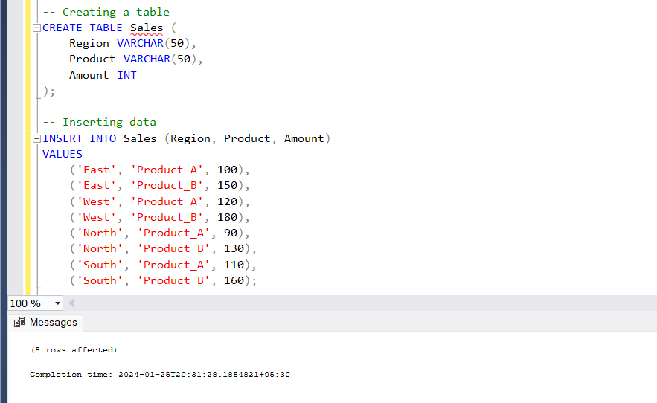

* Now we retrieve values to confirm whether it inserted or not

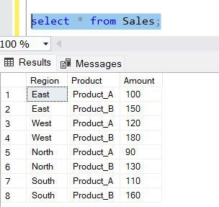

Now we create subtotals and grand totals using roll up

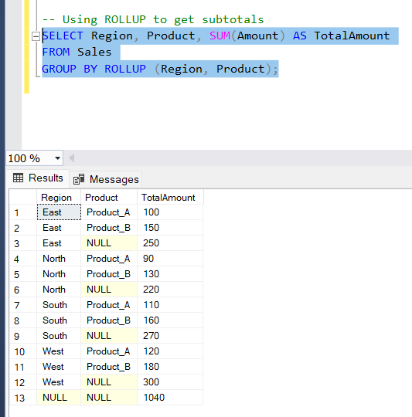

**Stored Procedure:**

A stored procedure is a precompiled collection of one or more SQL statements or procedural logic, which is stored as a database object. It is often used in database management systems to encapsulate and execute a set of SQL statements or procedural code on the database server.

* We use ‘create procedure’ keyword for this

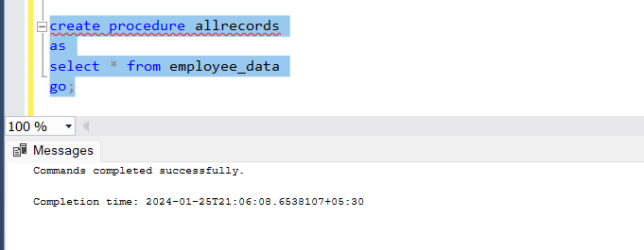

Here we create allrecords procedure and if we want to execute this we can use exec command

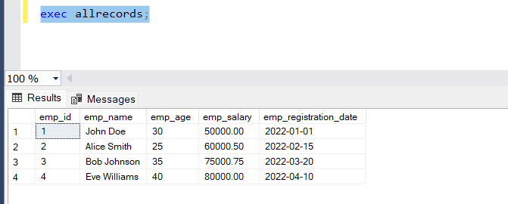

Now we create stored procedure for one parameter

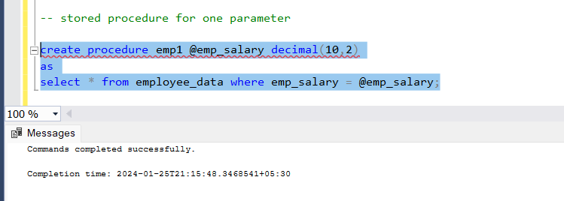

Now we execute this as same as above

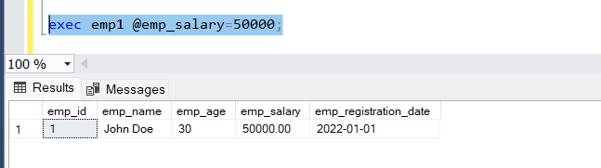

Now we create stored procedure for two parameters

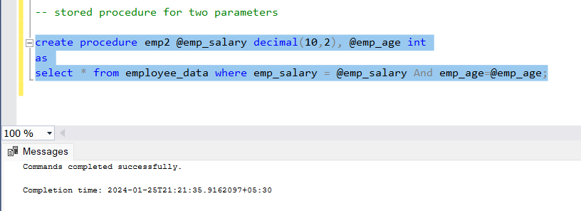

Now we execute same as above

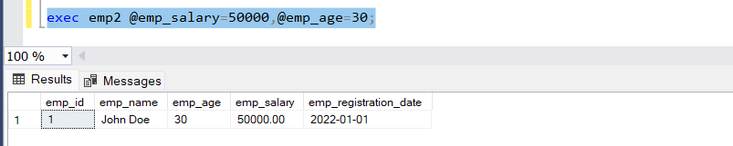

**Over and Partition by clauses in sql**

The OVER clause in SQL is used in combination with window functions to perform calculations across a set of rows related to the current row. The PARTITION BY clause is often used within the OVER clause to divide the result set into partitions to which the window function is applied.

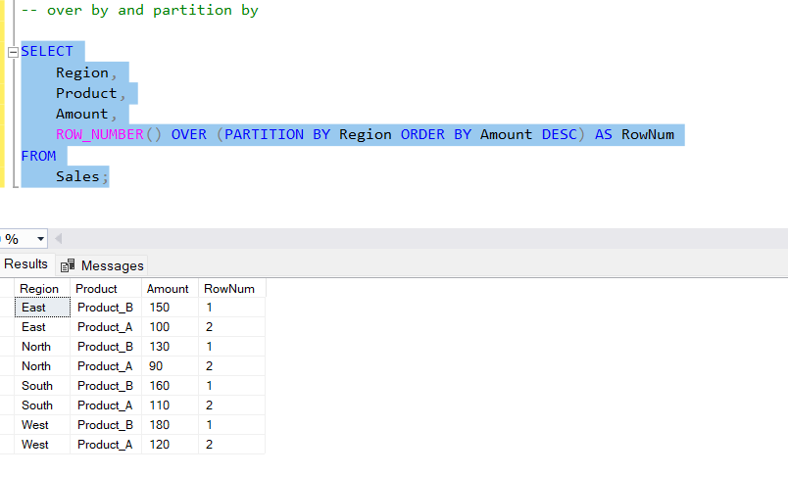

Using various aggregate functions with PARTITION BY and over by

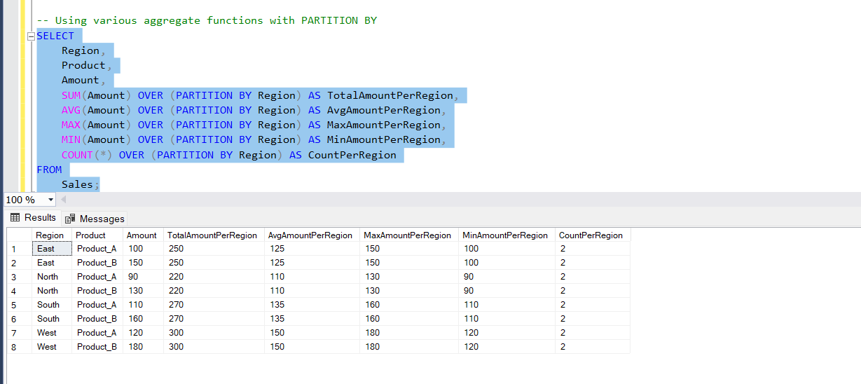

**Rank, Dense rank and row number**

For this purpose we create one table called ExamScores and insert some random variables

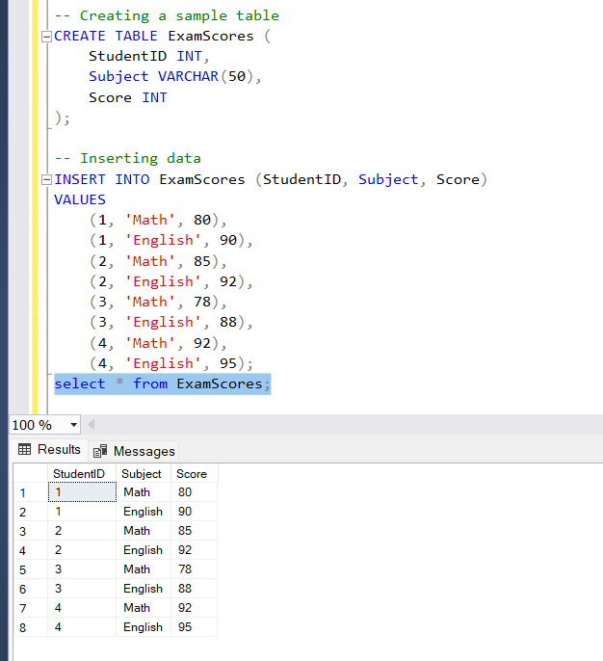

Now we perform rank,dense rank and row number

* Certainly! The RANK(), DENSE_RANK(), and ROW_NUMBER() window functions are used to assign a ranking to rows within a result set based on a specified order

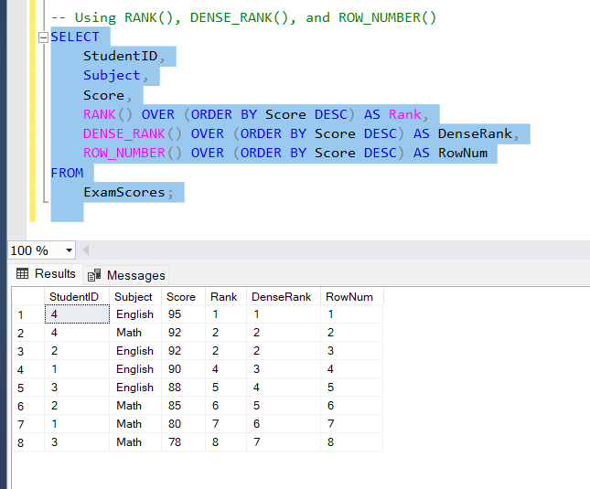

**View and materialized view:**

In SQL, a view is a virtual table based on the result of a SELECT query. It allows you to encapsulate complex queries and provide a simplified interface to the underlying data. On the other hand, a materialized view is a physical copy of the result set of a query, which is stored and can be refreshed to reflect changes in the underlying data.

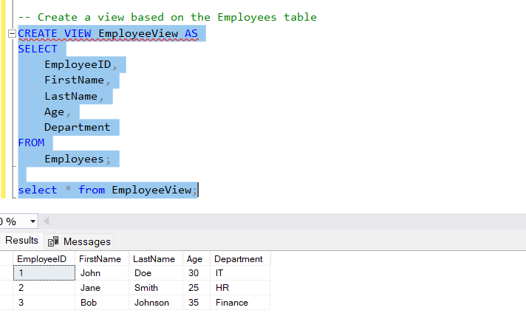

Materialized view does not support in sql server

**Star Schema:**

* In a star schema, there is a central fact table surrounded by dimension tables.
* The fact table contains quantitative data (measures), and dimension tables contain descriptive information related to the measures.
* This structure resembles a star when visualized, with the fact table at the center and dimensions radiating out like star points.

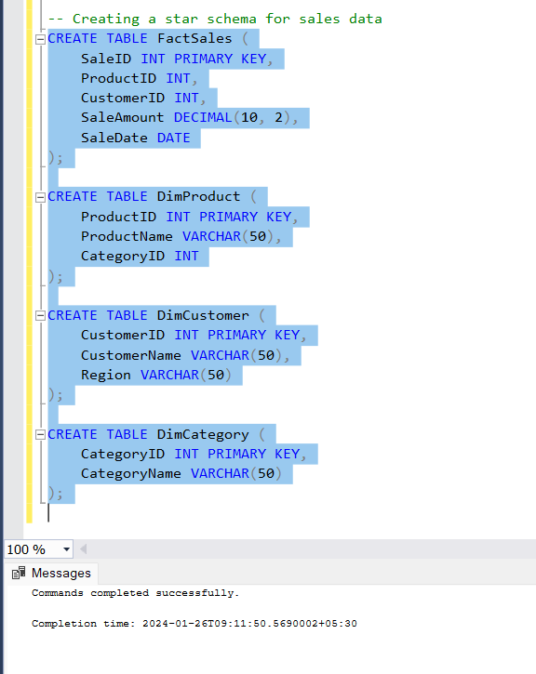

In this example, FactSales is the central fact table, and DimProduct, DimCustomer, and DimCategory are dimension tables.

**Snowflake Schema:**

* A snowflake schema is an extension of the star schema where dimensions are normalized into multiple related tables, forming a shape that resembles a snowflake.
* The goal is to reduce redundancy by breaking down hierarchies into separate tables.

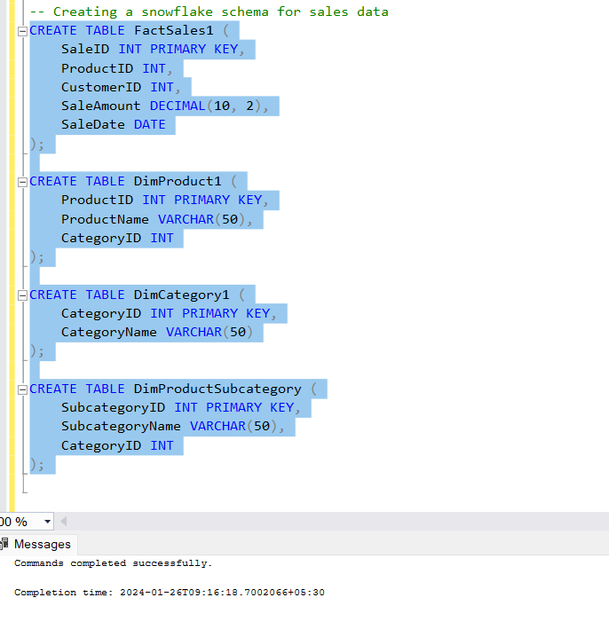

* In this example, DimProductSubcategory is added, and DimProduct1 is normalized into DimProduct1 and DimProductSubcategory.

The choice between star and snowflake schemas depends on the specific requirements and characteristics of the data warehouse and the queries it needs to support. Each schema has its own set of trade-offs and considerations.